Global Scope (Language-Dependent)

📌 Definition:
# Source: AI Source: Provided by: [Data Path: Persons Table -> ID Column: 1, Name_En Column: Motasem Essam] -> From: [Chatgpt (GPT‑5 Mini)] on [12/9/2025]
Global scope refers to variables or functions that are declared outside all classes, methods, or functions, and can be accessed from anywhere in the program (depending on the programming language).

🧠 Simple idea:
# Source: AI Source: Provided by: [Data Path: Persons Table -> ID Column: 1, Name_En Column: Motasem Essam] -> From: [Chatgpt (GPT‑5 Mini)] on [12/9/2025]
Global Scope = “Accessible everywhere” 🌐

🔍 Key characteristics:
# Source: AI Source: Provided by: [Data Path: Persons Table -> ID Column: 1, Name_En Column: Motasem Essam] -> From: [Chatgpt (GPT‑5 Mini)] on [12/9/2025]
- 🌍 Defined outside functions/classes
- 🔄 Accessible from any part of the program
- ⚠️ May lead to naming conflicts
- 🧠 Exists throughout the program’s execution
- 📌 Behavior depends on the programming language

📌 Example (Python):
# Source: AI Source: Provided by: [Data Path: Persons Table -> ID Column: 1, Name_En Column: Motasem Essam] -> From: [Chatgpt (GPT‑5 Mini)] on [12/9/2025]
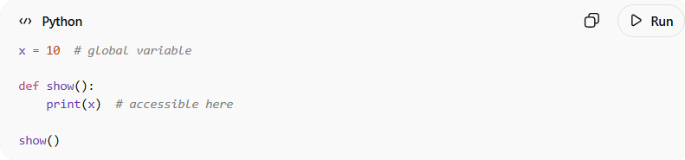
x = 10 # global variable

def show():
print(x) # accessible here

show()

📌 Example (JavaScript):
# Source: AI Source: Provided by: [Data Path: Persons Table -> ID Column: 1, Name_En Column: Motasem Essam] -> From: [Chatgpt (GPT‑5 Mini)] on [12/9/2025]
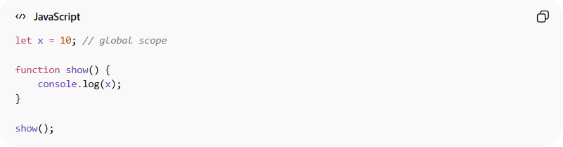
let x = 10; // global scope

function show() {
console.log(x);
}

show();

⚠️ In Java:
- ❌ Java does not support true global variables
- ✅ Instead, it uses:
  - static variables
  - class-level fields

📌 Example (Java using static):
# Source: AI Source: Provided by: [Data Path: Persons Table -> ID Column: 1, Name_En Column: Motasem Essam] -> From: [Chatgpt (GPT‑5 Mini)] on [12/9/2025]
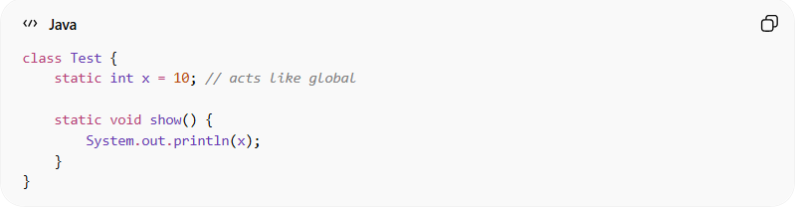
class Test {
static int x = 10; // acts like global

static void show() {
System.out.println(x);
}
}

🎯 Why global scope is important:
# Source: AI Source: Provided by: [Data Path: Persons Table -> ID Column: 1, Name_En Column: Motasem Essam] -> From: [Chatgpt (GPT‑5 Mini)] on [12/9/2025]
- 🌍 Useful for shared data
- 🔄 Accessible across multiple parts of a program
- ⚙️ Helps in certain configurations and constants

⚠️ Risks of global scope:
# Source: AI Source: Provided by: [Data Path: Persons Table -> ID Column: 1, Name_En Column: Motasem Essam] -> From: [Chatgpt (GPT‑5 Mini)] on [12/9/2025]
- ❌ Hard to manage in large programs
- ❌ Can lead to unexpected changes
- ❌ Reduces code safety and modularity

🎯 Summary:
# Source: AI Source: Provided by: [Data Path: Persons Table -> ID Column: 1, Name_En Column: Motasem Essam] -> From: [Chatgpt (GPT‑5 Mini)] on [12/9/2025]
Global scope allows variables and functions to be accessed from anywhere in the program, but its use should be controlled to avoid complexity and errors.

